Exploring the factors affecting Attrition

Himani Malhotra

20/01/2025

Attrition Analytics - Exploratory Analysis & Predictive Modelling

Problem Statement:

Human Resources are critical resources of any organization. Organizations spend huge amount of time and money to hire and nurture their employees. It is a huge loss for companies if employees leave, especially the key resources. Reasons for attrition can be plenty and range from dissatisfaction due to low salaries, less or no career growth opportunities, inferior employee supervision, eagerness to get into companies with global presence, lack of recognition, lack of freedom of expression in the organization and underutilization of talents and skills of the individuals. Thus in a situation when more and more employees are quitting the organization, the attrition rate is on a rise. So if HR can predict weather employees are at risk for leaving the company, it will allow them to identify the attrition risks and help understand and provide necessary support to retain those employees or do preventive hiring to minimize the impact to the organization.

Objective:

The objective of the present report is to study factors like salary, satisfactory level, growth opportunities, facilities, policies and procedures, recognition, appreciation, suggestions of the employee’s by which it helps to know the Attrition level in the organizations and factors relating to retain them. This study also helps to find out where the organizations are lagging in retaining.

Exploratory Data Analysis:

Attrition Vs Age: Hypothesis: Age has impact on attrition.

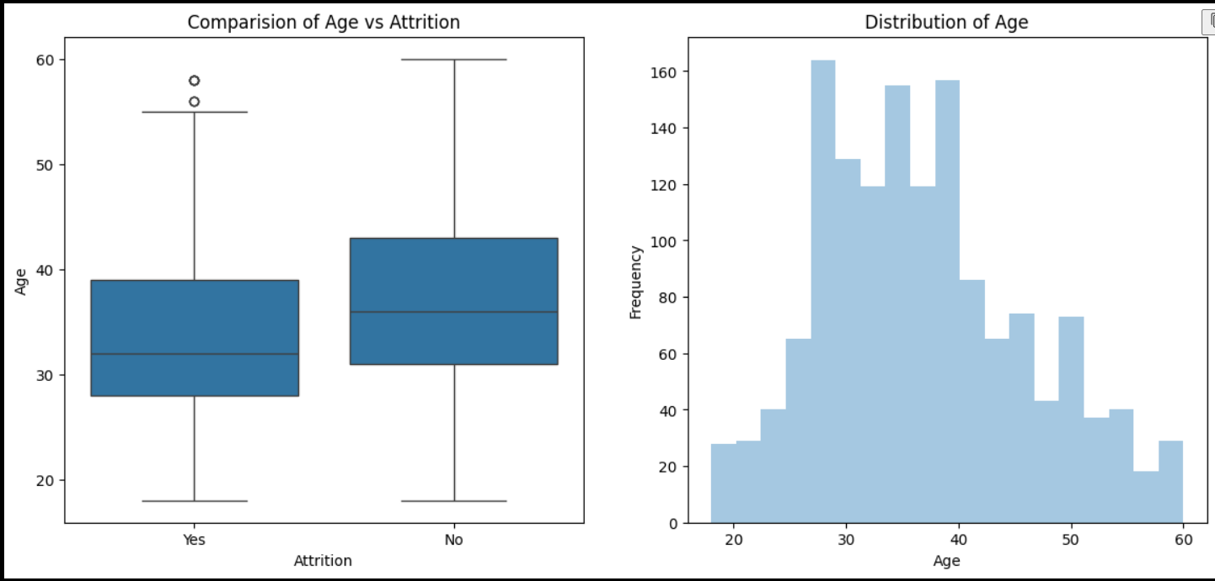

* We found that median age of employee's in the company is 30 - 40 Yrs. Minimum age is 18 Yrs. and Maximum age is 60 Yrs. 2.
* From the Age Comparison boxplot, majority of people who left the company are below 40 Yrs. and among the people who didn't left the company are of age 32 to 40 years. Age has an effect on attrition.

So it is considered as influential variable for attrition.

Attrition Vs Daily Rate, Monthly Rate, Hourly Rate:

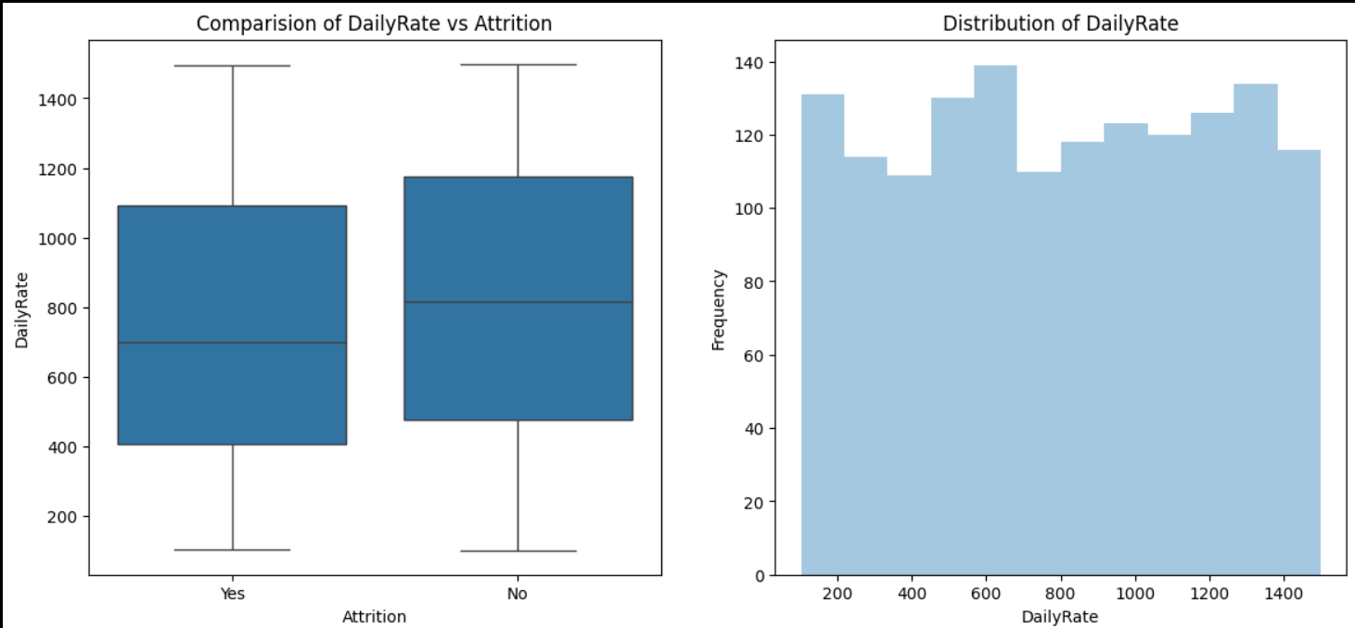

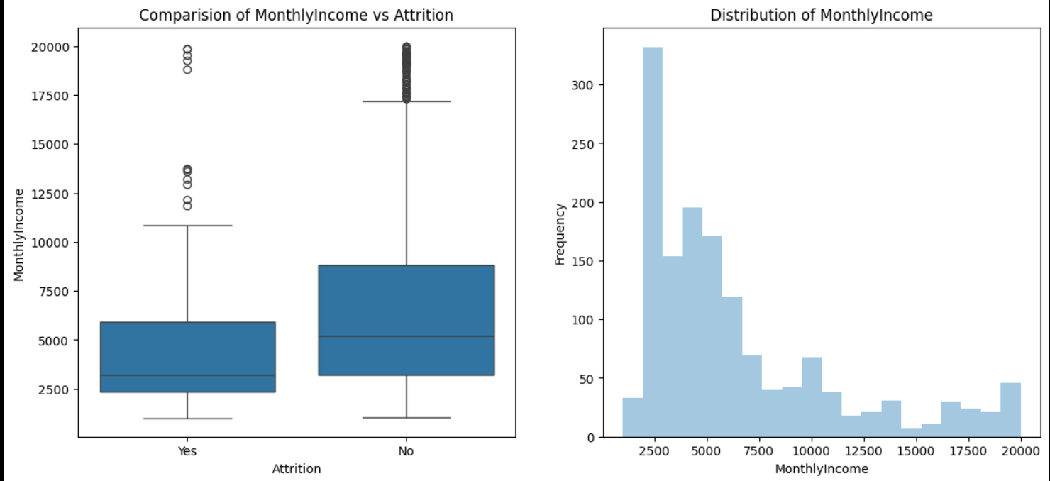

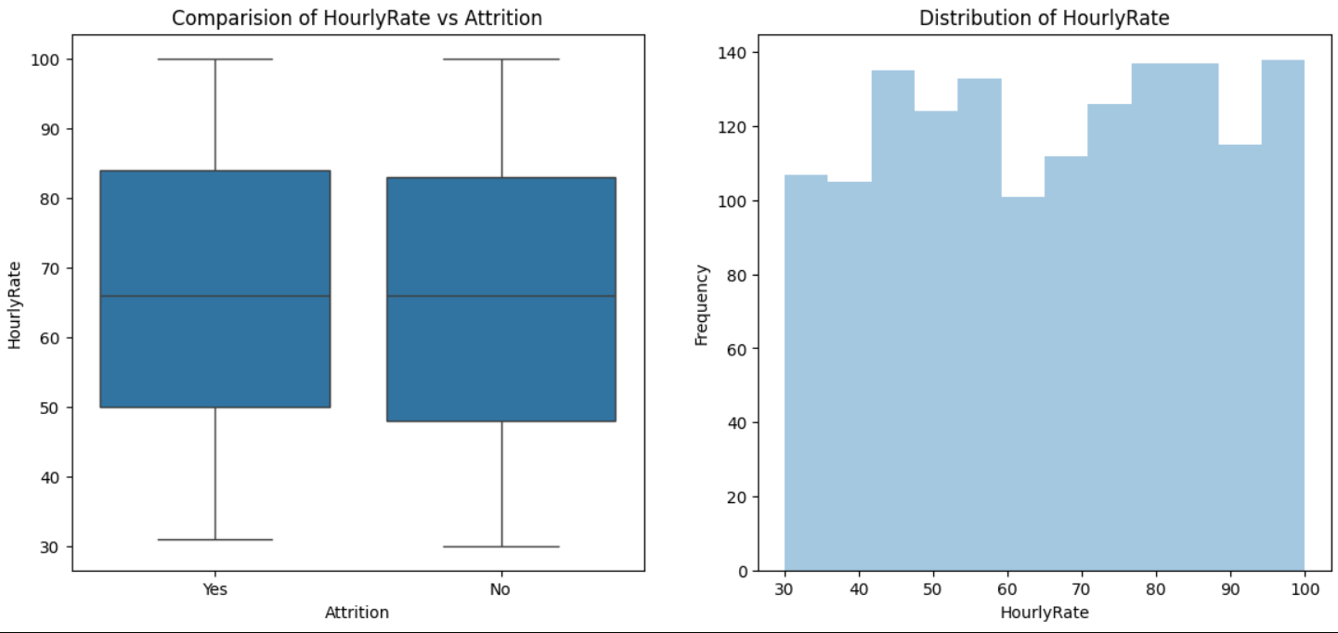

* Employee's working with lower daily rates are more prone to leave the company than compared to the employee's working with higher rates. The same trend is resonated with monthly income too

Attrition Vs Percent Salary Hike:

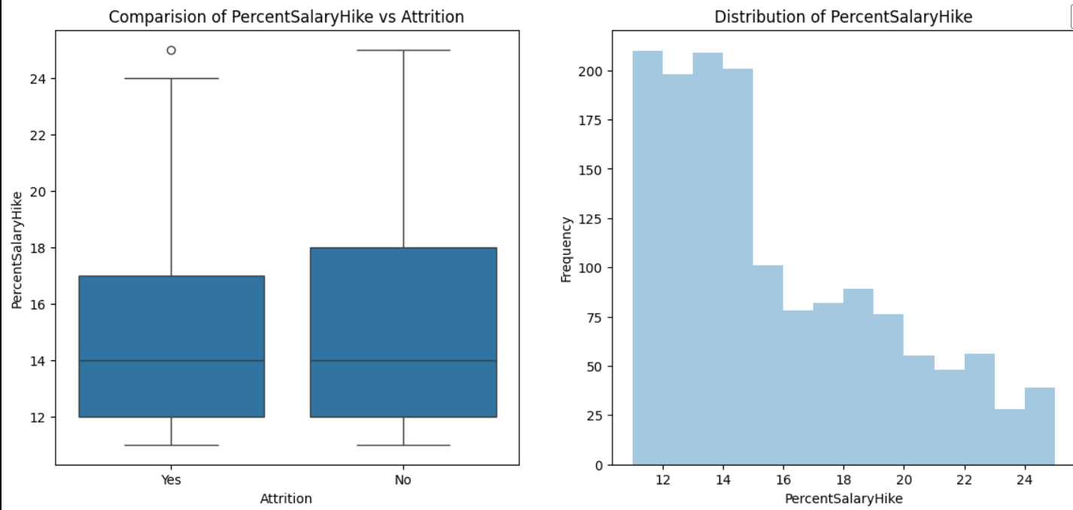

* Majority (60% of total strength) of employee's receive 16% salary hike in the company, employees who received less salary hike have left the company. So percent salary is considered has significant effect on attrition and is considered as important variable

Attrition Vs Total Working Hours:

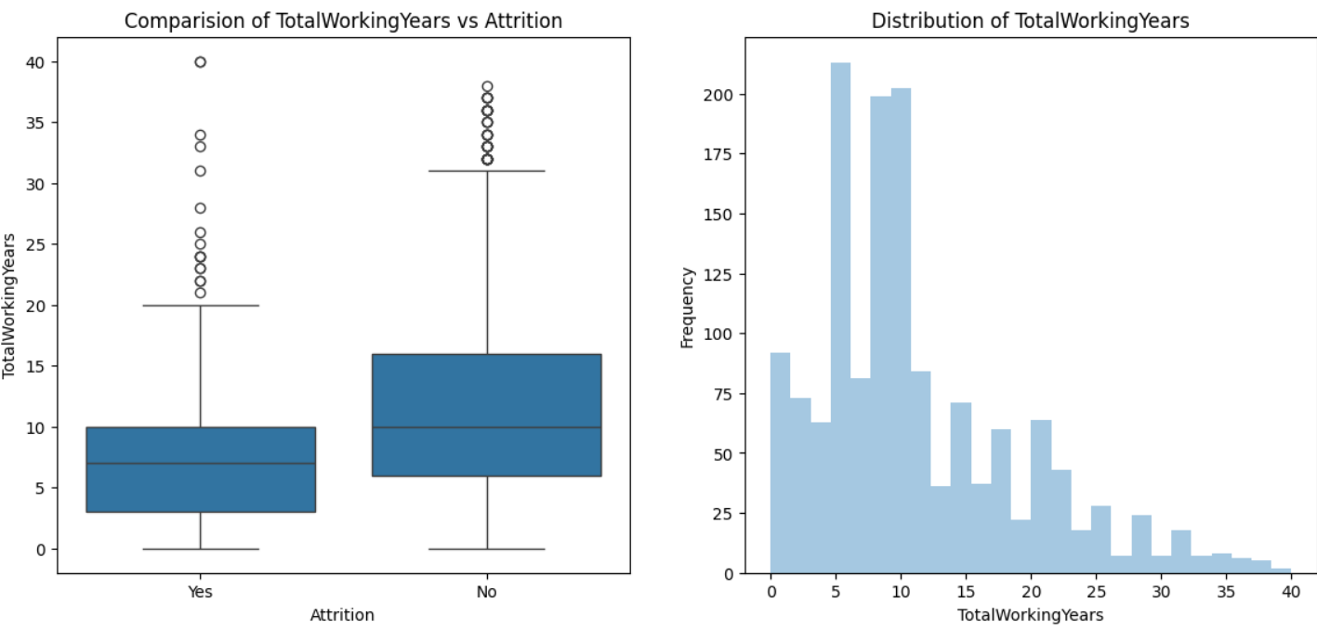

* Employee's with less working years have received 25% Salary hike when they switch to another company, but there is no linear relationship between working years and salary hike.
* Attrition is not seen among the employee's having more than 20 years of experience if their salary hike is more than 20%, even if the salary hike is below 20% attrition rate among the employee's is very low.
* Employee's with lesser years of experience are prone to leave the company in search of better pay, irrespective of salary hike.

So percent salary hike and total working years together has and effect of attrition and is considered as important variable.

Attrition Vs Distance From Home:

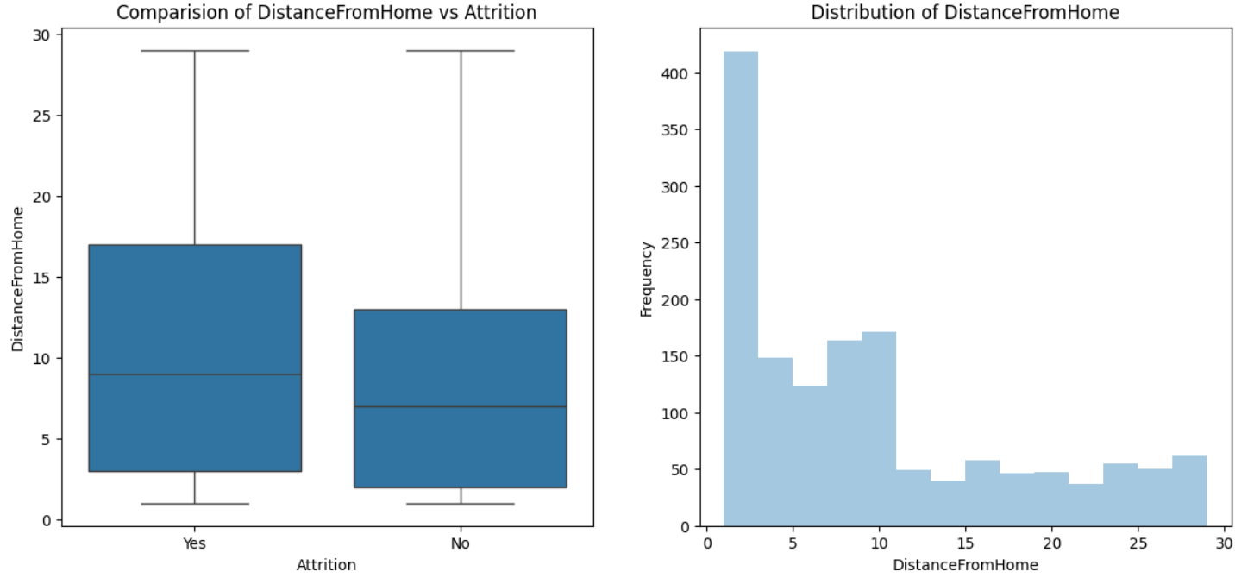

* There is a higher number of people who reside near to offices and hence the attrition levels are lower for distance less than 10. With increase in distance from home, attrition rate also increases.

So it is observed that distance from home has significant effect on attrition.

Attrition Vs Job Involvement:

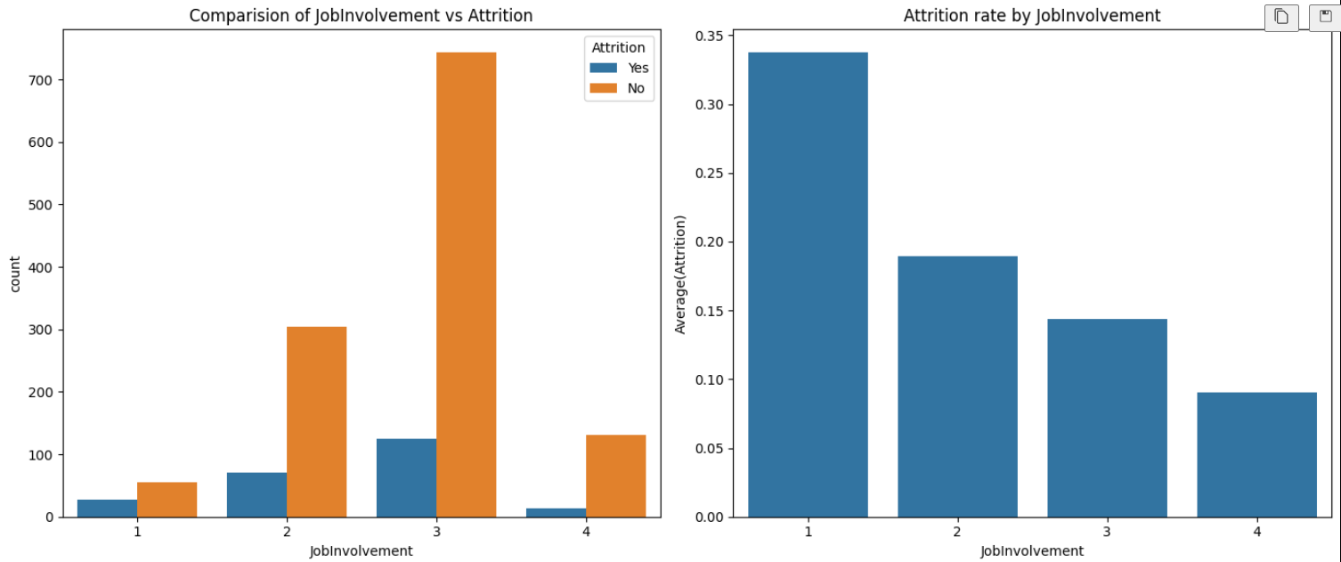

1. In the total data set, 59% have high job involvement whereas 25% have medium involvement rate

2. From above plot we can observe that round 50% of people in low job involvement (level 1 & 2) have left the company.

3. Even the people who have high job involvement have higher attrition rate around 15% in that category have left company.

Attrition Vs Job Satisfaction:

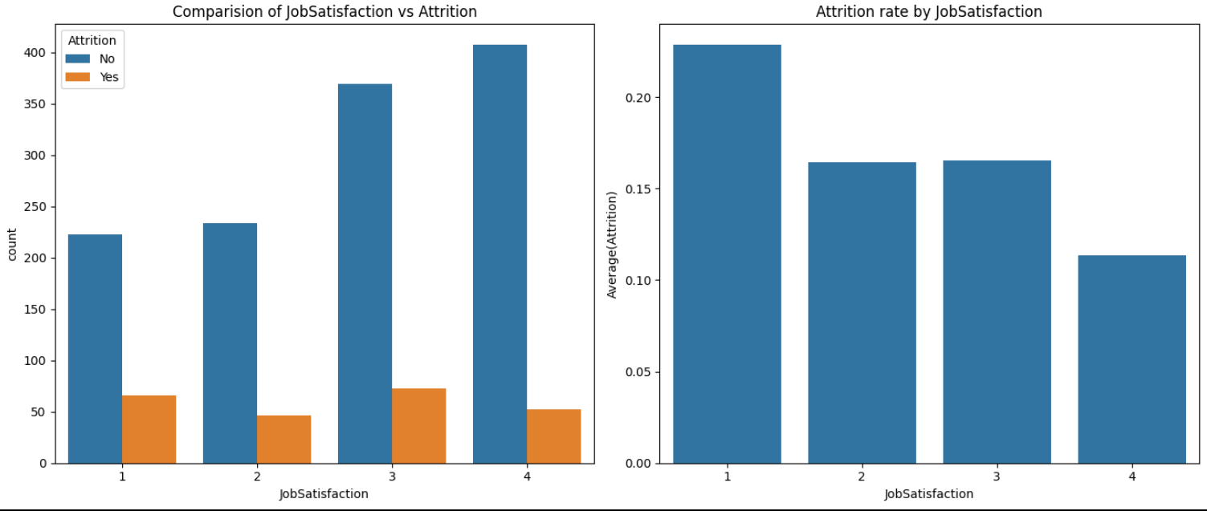

As expected, people with low satisfaction have left the company around 23% in that category. what surprising is out of the people who rated medium and high job satisfaction around 32% has left the company. There should be some other factor which triggers their exit from the company

Attrition Vs Performance Rating:

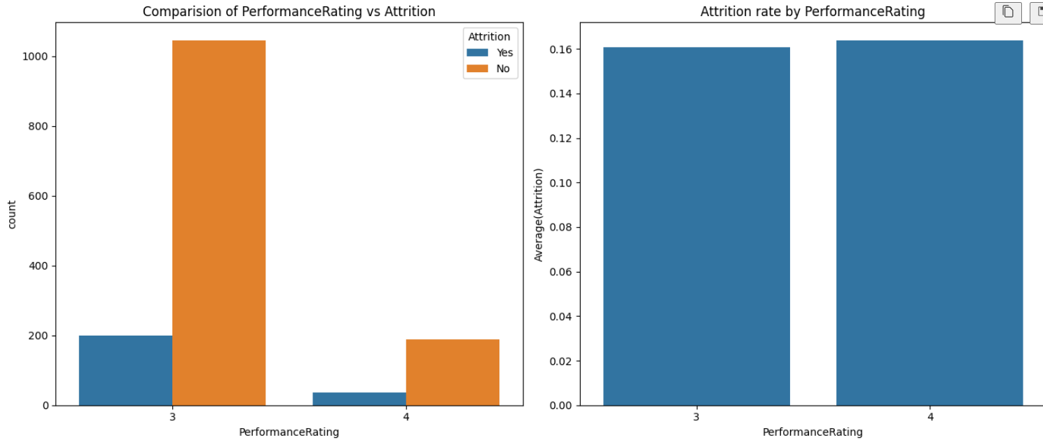

Contrary to normal belief that employee's having higher rating will not leave the company. It may be seen that there is no significant difference between the performance rating and Attrition Rate.

Attrition Vs Overtime:

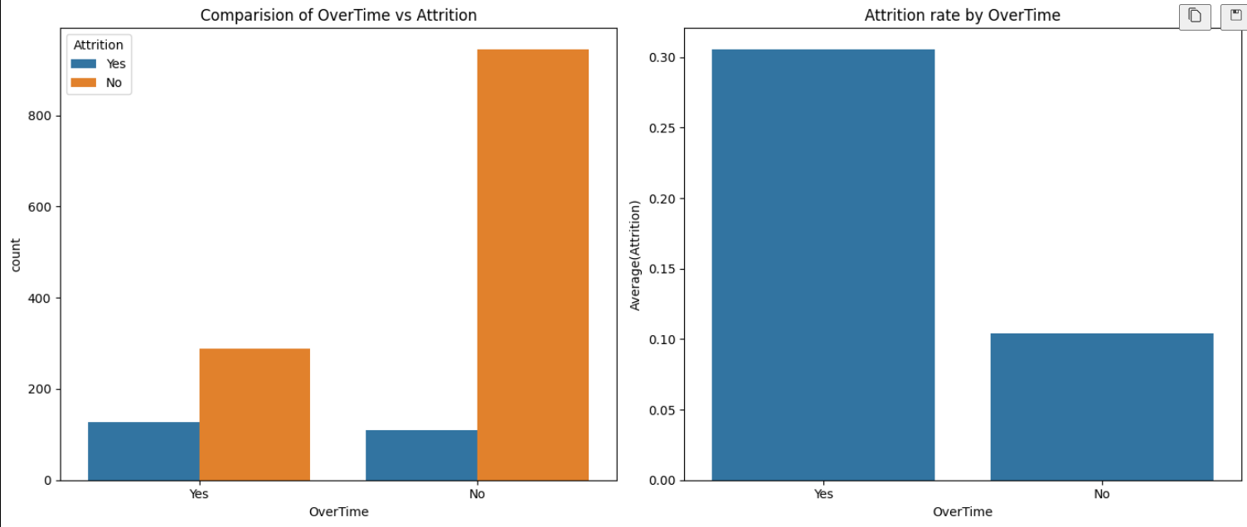

More than 30% of employee's who worked overtime has left the company, where as 90% of employee's who have not experienced overtime has not left the company. Therefore overtime is a strong indicator of attrition

Attrition Vs Business Travel:

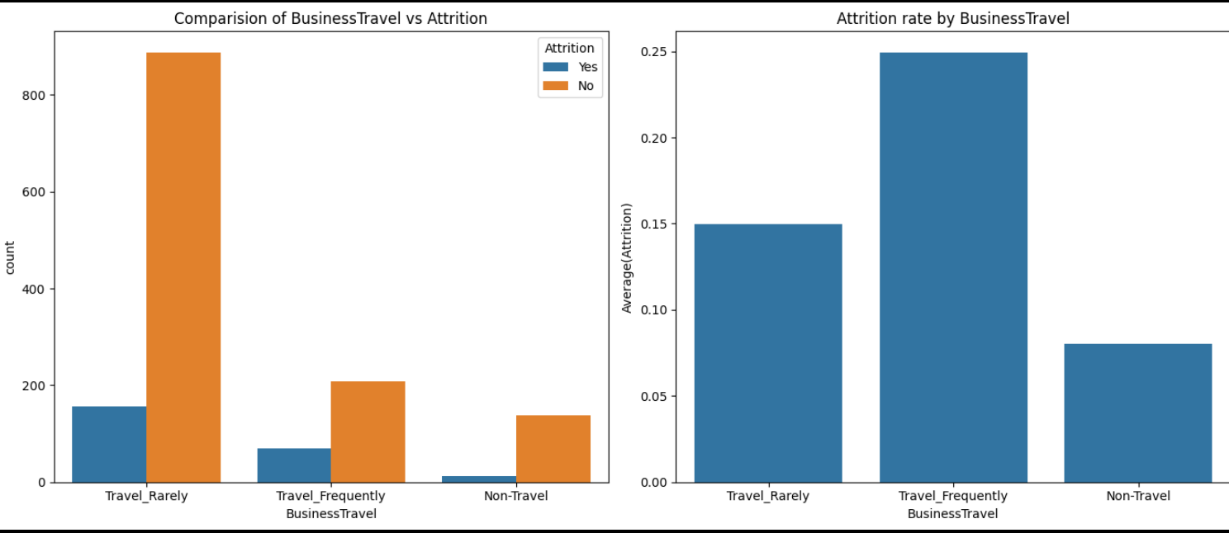

There are more people who travel rarely compared to people who travel frequently. In case of people who travel Frequently around 25% of people have left the company and in other cases attrition rate doesn't vary significantly on travel

Attrition Vs Department:

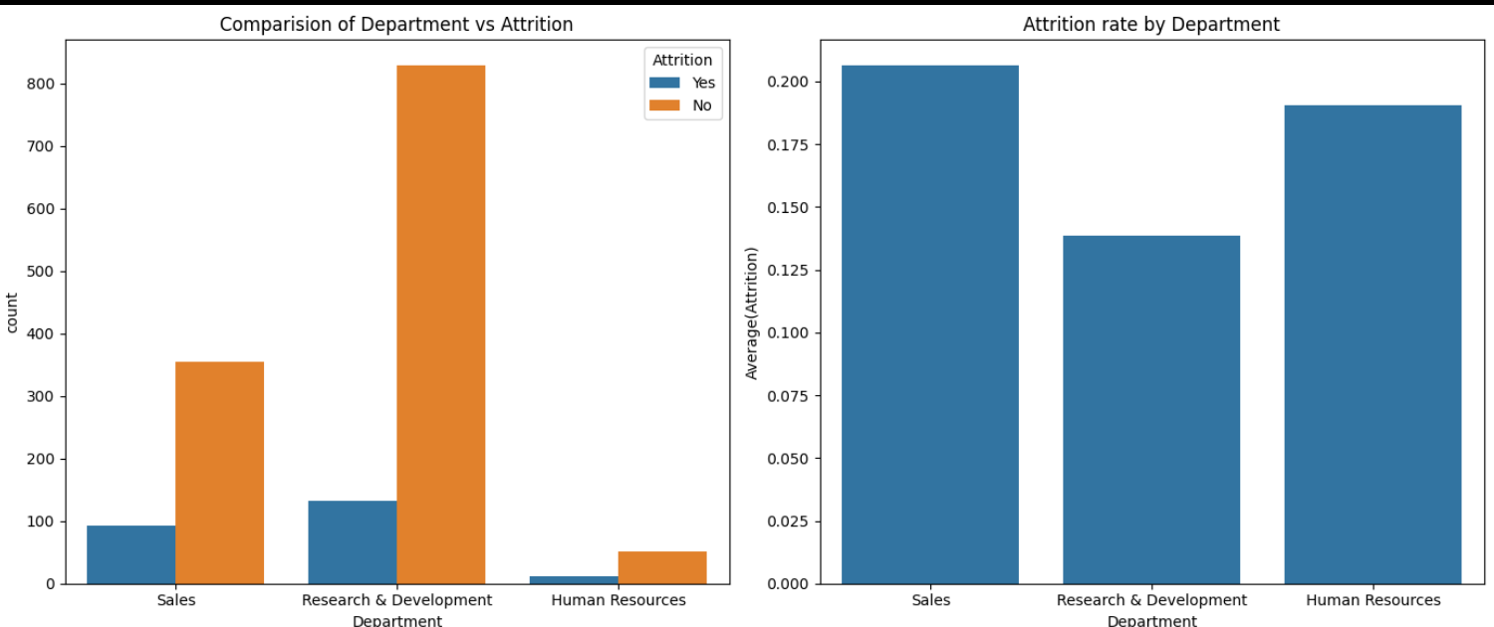

1. On comparing department wise, we can conclude that HR has seen only a marginal high in turnover rates whereas the numbers are significant in sales department with turnover rates of 39 %. The attrition levels are not appreciable in R & D where 67 % have recorded no attrition.

2. Sales has seen higher attrition levels about 20.6% followed by HR around 18%.

Attrition Vs Education Field:

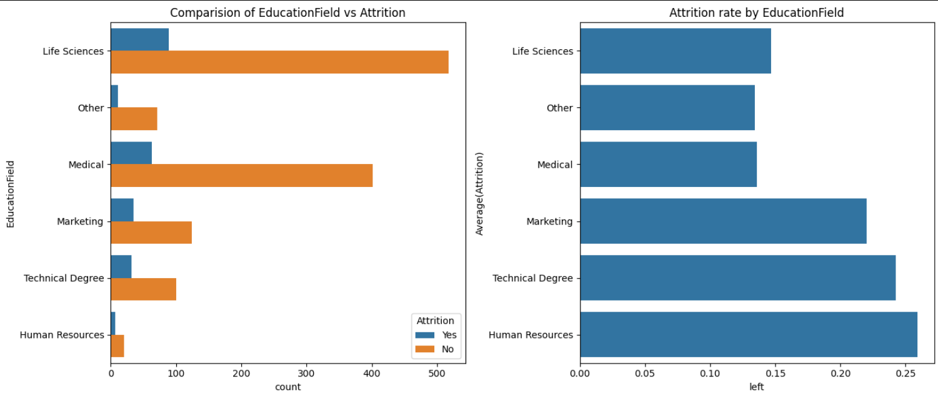

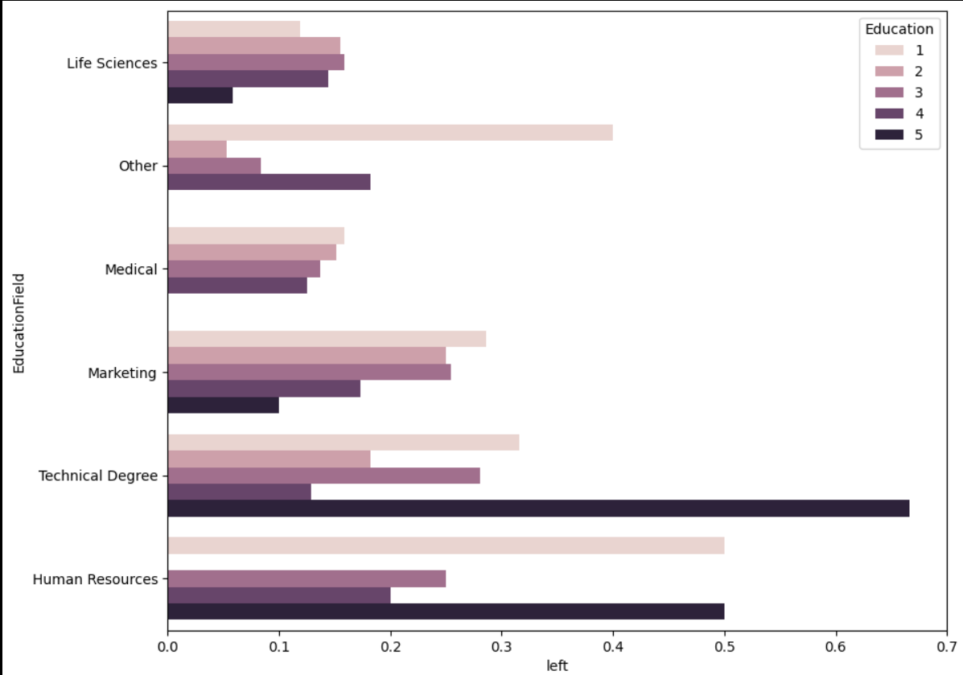

1. There are more people with a Life sciences followed by medical and marketing.

2. Employee's in the Education Field of Human Resources and Technical Degree have highest attrition levels around 26% and 23% respectively. 3. When compared with Education level, we have observed that employees in the highest level of education in their field of study have left the company. We can conclude that Education Field is a strong indicator of attrition.

Attrition Vs Environmental Satisfaction:

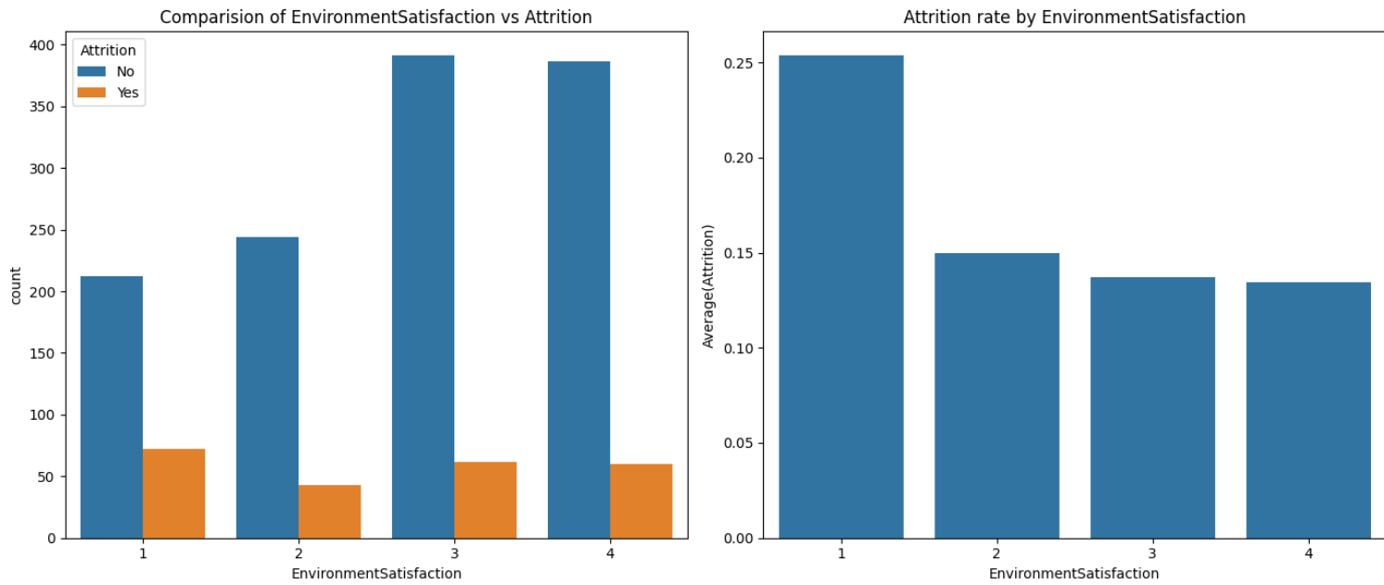

We can see that people having low environment satisfaction 25% leave the company.

Attrition Vs Job Role:

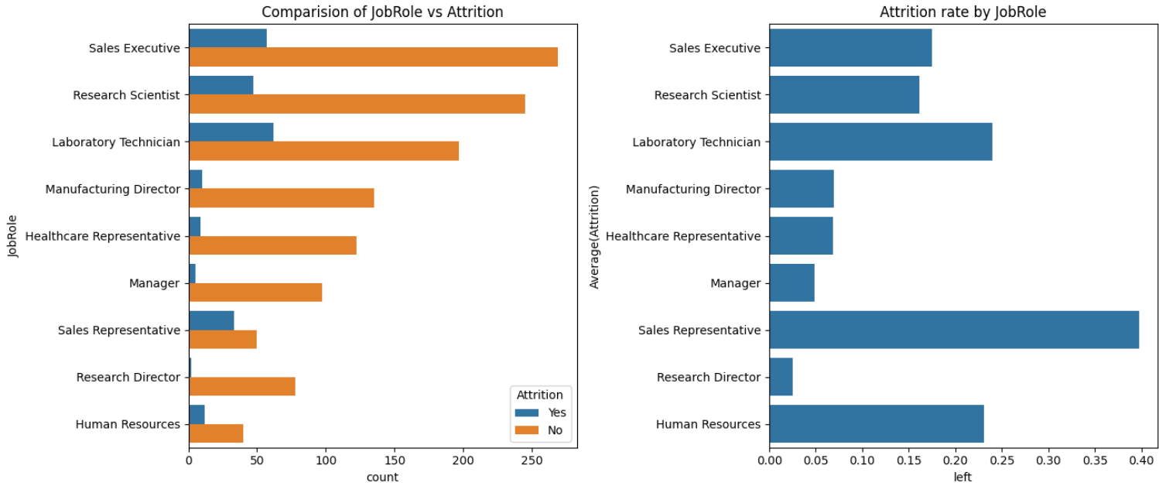

1. Jobs held by the employee is maximum in Sales Executive, then R&D , then Laboratory Technician

2. People working in Sales department is most likely quit the company followed by Laboratory Technician and Human Resources there attrition rates are 40%, 24% and 22% respectively.

Attrition Vs Marital status:

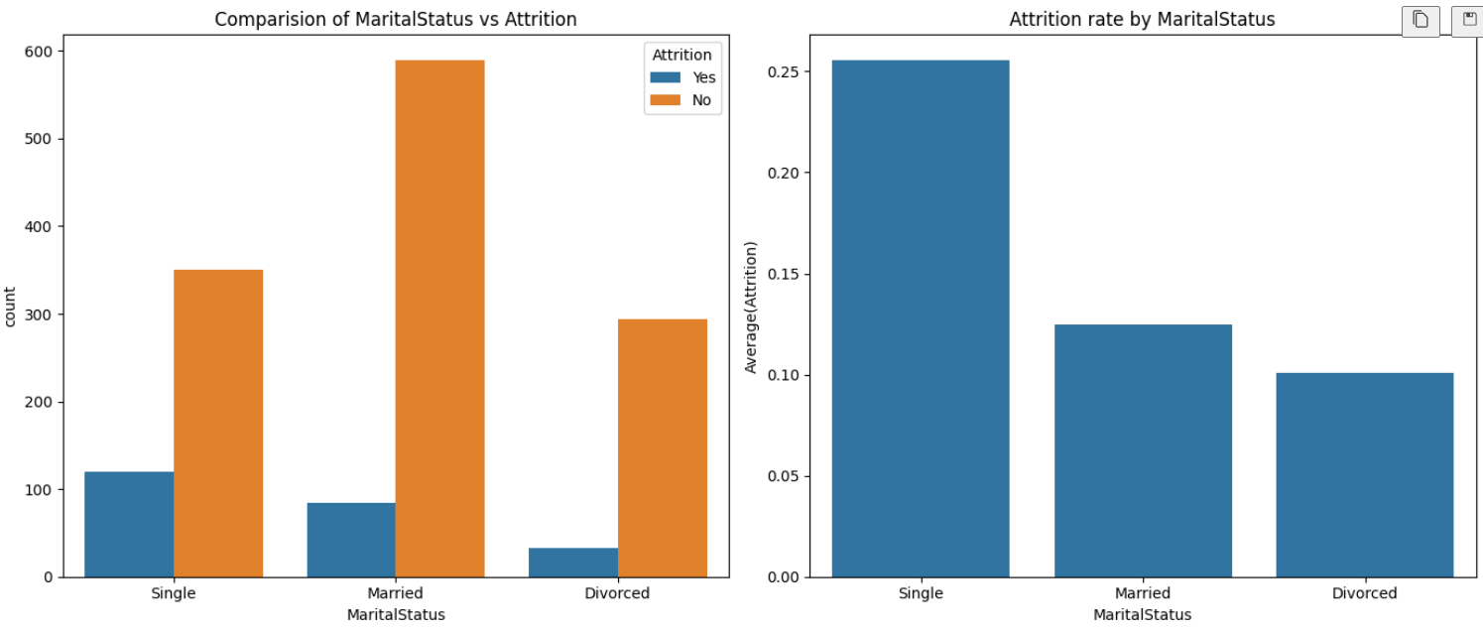

From the plot, it is understood that irrespective of the marital status, there are large people who stay with the company and do not leave. Therefore, marital status is a weak predictor of attrition